**Assignment 04 – Wireshark and Snort IDS**

* **Installing snort and wire shark:**

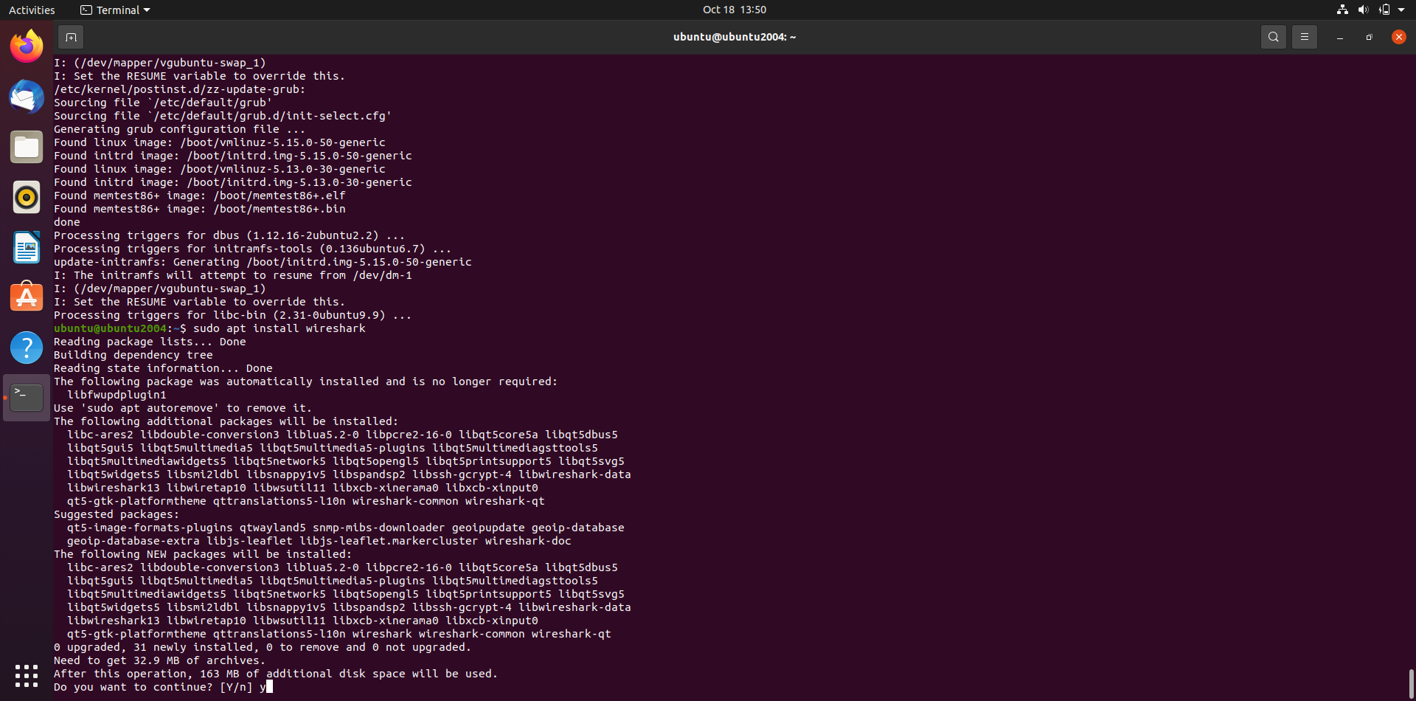

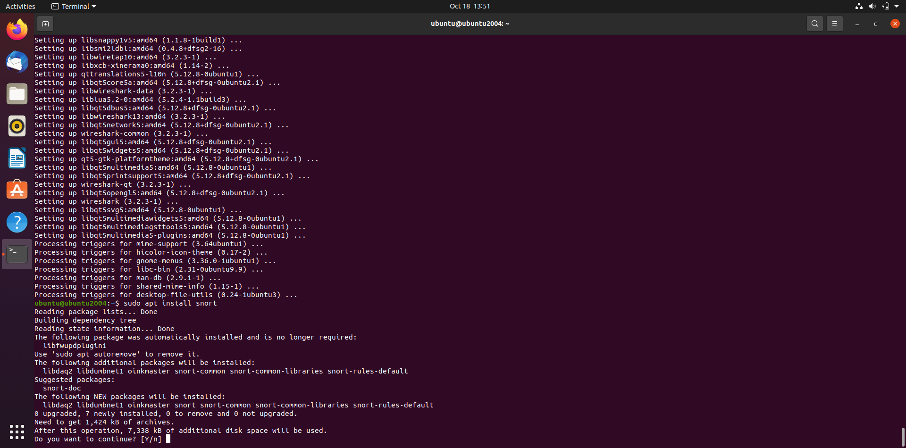

* **Using snort in verbose mode**

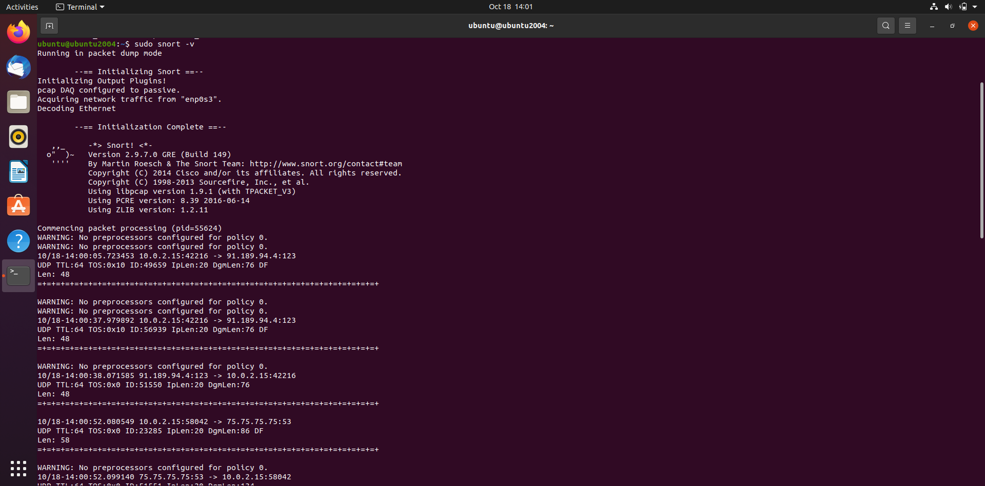

* **Information shown when snort is stopped**

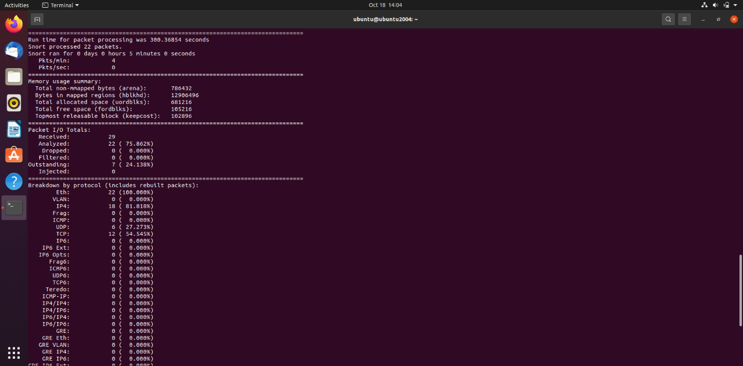

* **Pinging Ubuntu VM from local machine**

* **Pinging 127.0.0.1 while running snort**

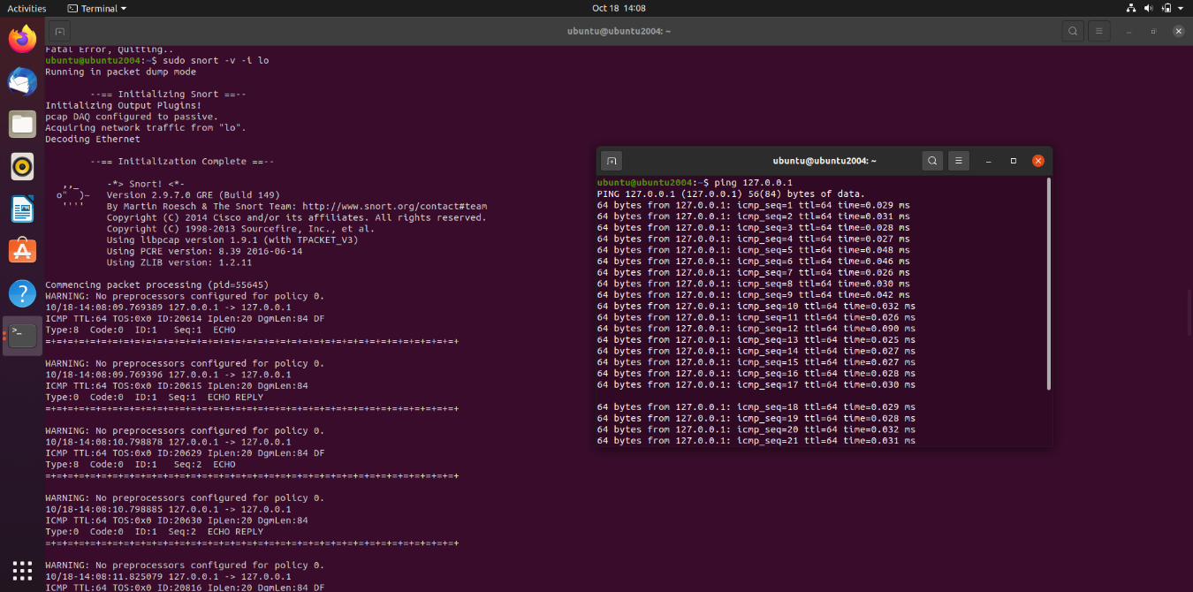

* **Running snort to display information about layer 3 and layer 4**

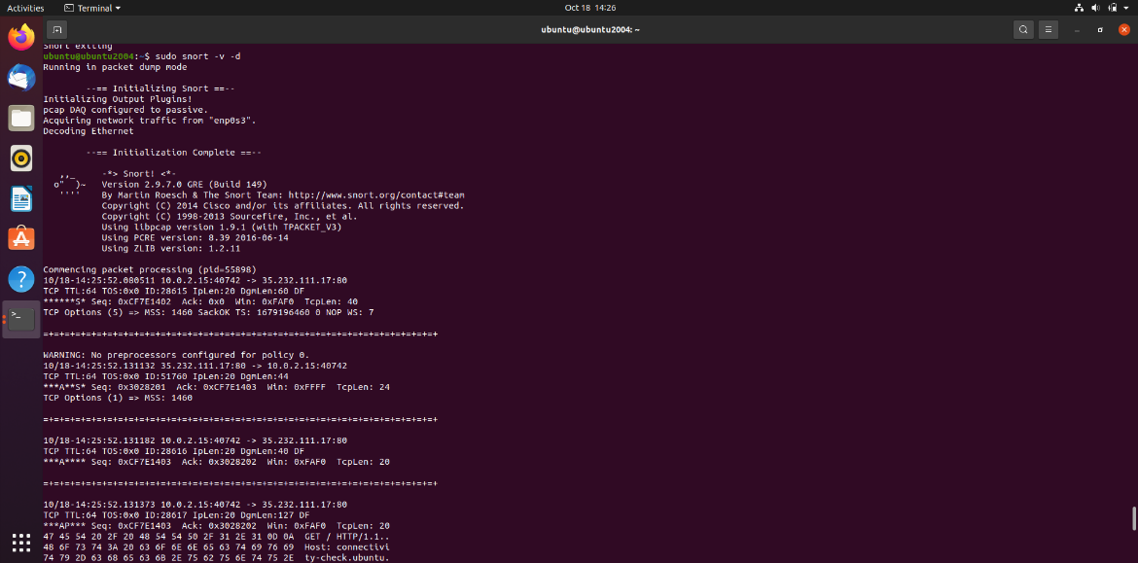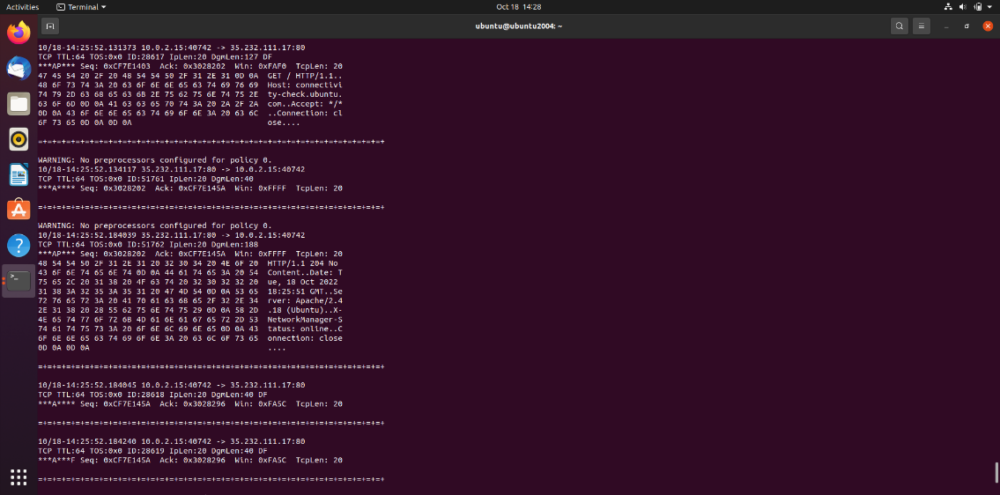

* **Running snort with -vde** 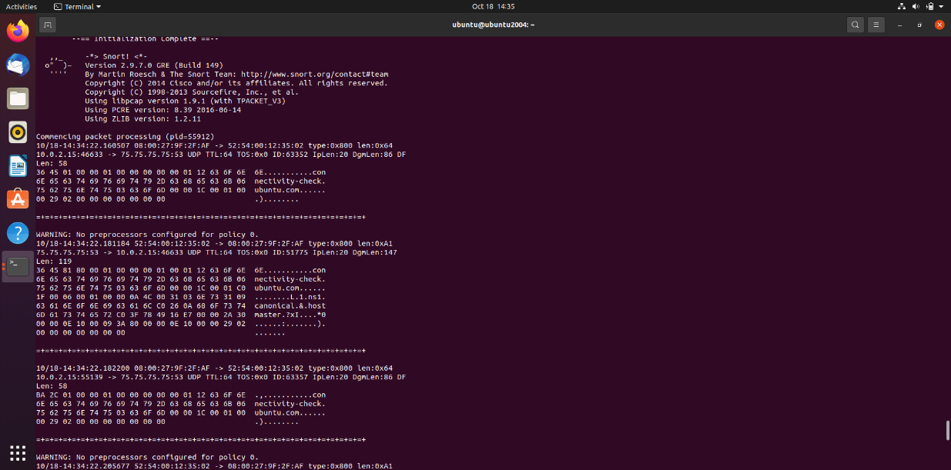
* **Files generated when pinging Ubuntu VM from local windows machine**

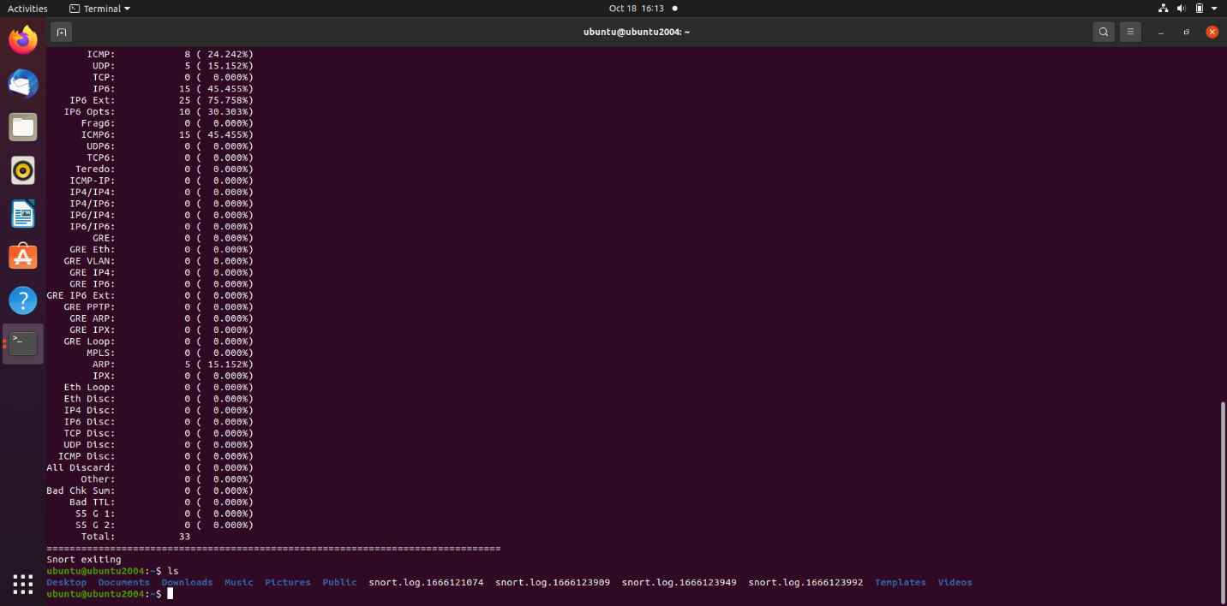

* **Inspecting log file with wireshark**

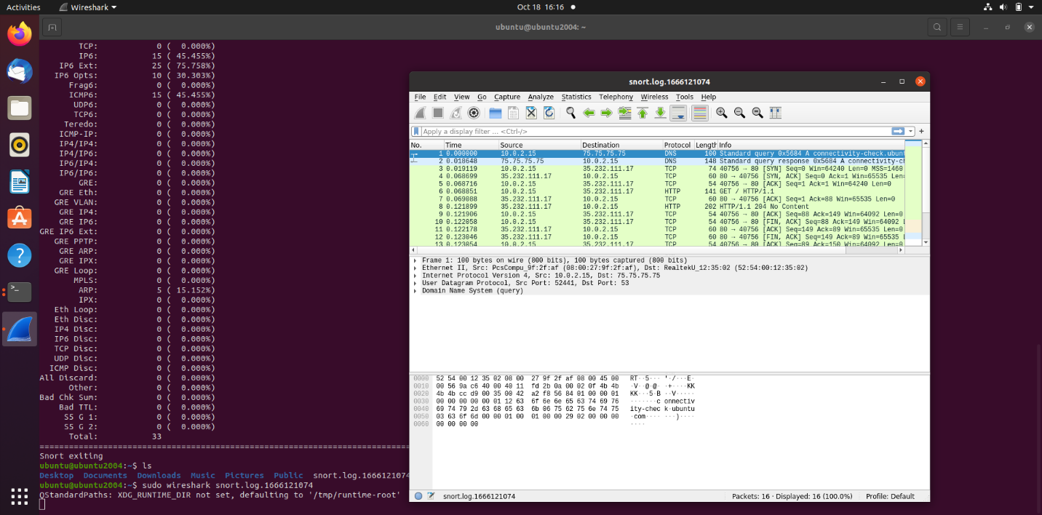

* **Adding rules to snort**

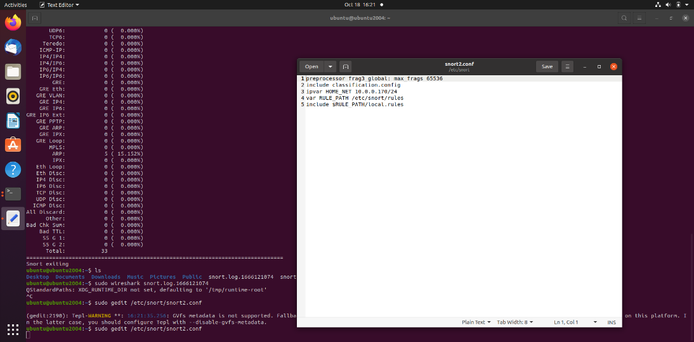

* **Pinging from windows local machine to Ubuntu VM after rules are set**

* **Inspecting log file with wireshark**

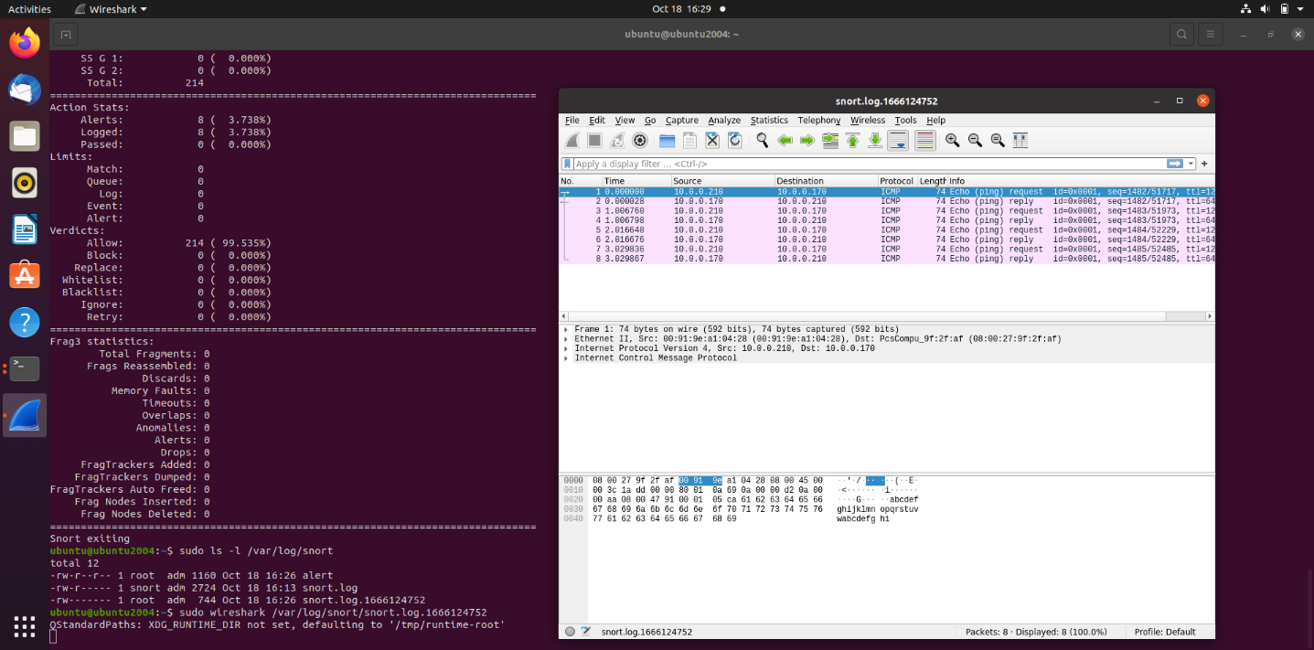

* **Pinging after changing the -A value from fast to full:**

* **Inspecting alert file**

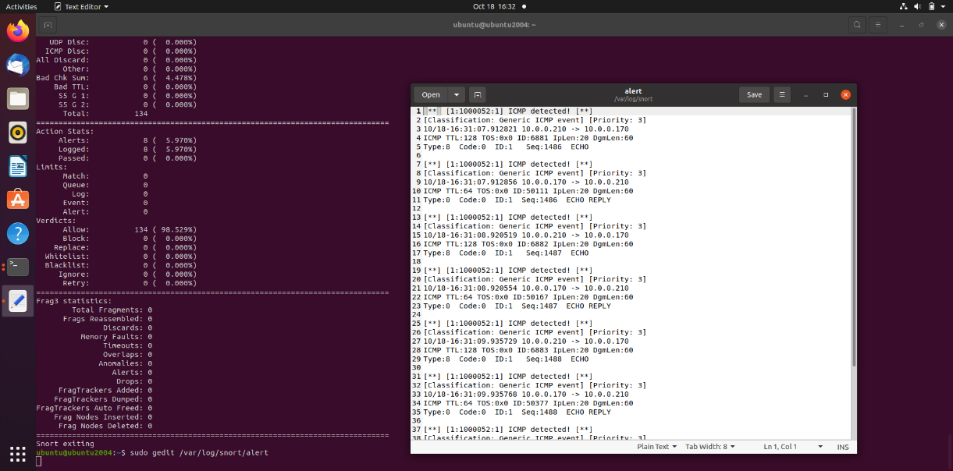

* **Pinging with both full and fast and two -A** 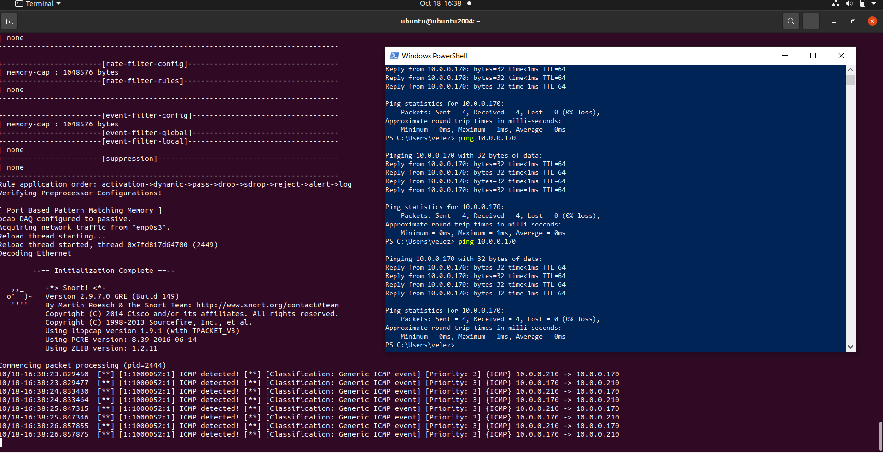
* **Inspecting log file**

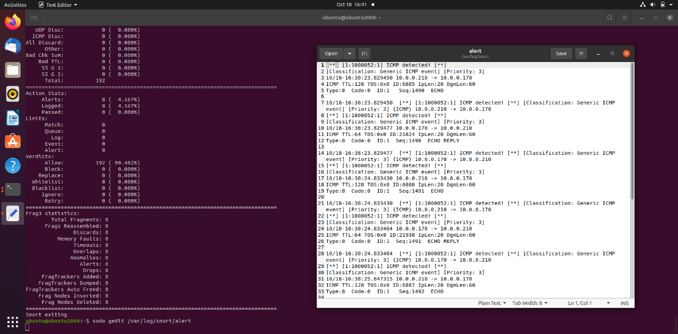

* **snort rules**

